Sean Dixon ’09 M.E.M.
Pace Law Joint Degree Program (JD w/ Environmental Law Certificate, '09), LLM (Climate Change Law, '10)
Staff Attorney, Riverkeeper
Co-Founder, Village Fishmonger NYC
Council Member, American Bar Association's Section of Environment, Energy and Resources Law
Adjunct Professor, Pace Law School

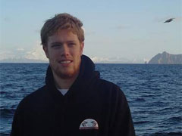
For my day job, I'm working on urban water issues - from sewage and toxics to green infrastructure and superfund remediation - as well as energy issues (crude oil transport, natural gas production, energy exports), climate resilience and adaptation, citizen enforcement, and public access. For the rest, it's all about telling the story of local, responsible seafood (and getting it into the hands of the people); helping build the profession of environmental law and policy, and teaching about oceans, coasts, rivers and lakes.

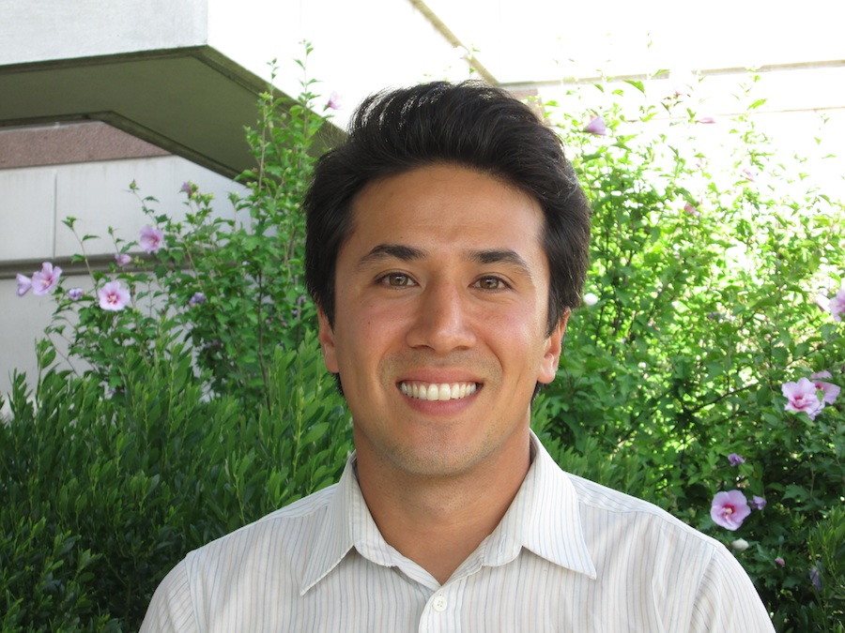
Justin Freiberg ’10 M.E.Sc.
West Campus Urban Farm and Sustainability Project Manager, Yale Sustainable Food Program
Co-Founder, Encendia Biochar

I am currently developing a program that will invite and incite sustainability-focused innovations on the Yale West Campus Urban Farm as well as the wider landscape of West Campus. Also, of course, I’m shepherding along the Farm, with the help of many volunteers and collaborators.
Tim Northrop ’03 M.E.M.
Director, Office of Development & Alumni Services, Yale F&ES, Panel Moderator
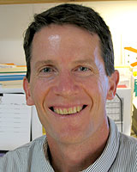
Tim serves as the Director of Development and Alumni Services for F&ES and oversees all aspects of philanthropy and alumni relations for the School. Prior to coming to Yale, Tim served as the State Director of the Trust for Public Land’s Connecticut Office for 9 years. He also worked for several years as an environmental professional in the private sector where he consulted with government and industry in the fields of solid and hazardous waste management, air quality compliance, and permitting. Tim is a graduate of the Coro Foundation’s Fellows Program in Public Affairs and a Returned Peace Corps Volunteer from Sierra Leone, West Africa. He has a B.A. in Human Biology from Stanford University, a Master’s in Environment Management from Yale F&ES, and certificates in Solid Waste Management & Recycling, and Hazardous and Toxic Waste Management from UCLA.
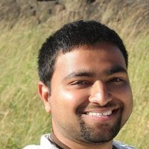
Ankur Garg ’13 M.E.M.
Senior Consultant, Policy Advisory and Research, Sustainable Energy Use, DNV GL – Energy

I mostly work on the evaluation of utility operated Demand Side Energy Management (DSM) Programs. My day-today work mostly involves performing statistical and econometric analysis on energy data collected on site or metering data.

Ben Healey ’12
M.E.M. /M.B.A.
Senior Manager of Clean Energy Finance, State of Connecticut Green Bank
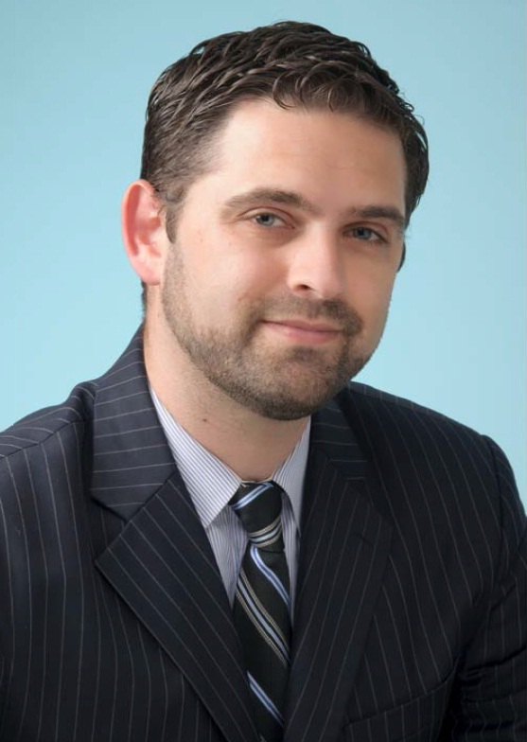
I am currently working on using power purchase agreement (PPA) financing together with the Green Bank's
Commercial Property Assessed Clean Energy (C-PACE) program to accelerate the deployment of distributed solar projects across commercial, not-for-profit, and municipal customers in Connecticut.

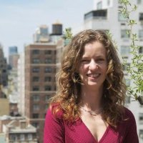
Walker Holmes ’10 M.E.M.
Urban Program Manager, The Trust for Public Land
Senior Associate, Skeo Solutions

I am currently renovating parks and schoolyards in Bridgeport, CT, for The Trust for Public Land and working with community groups on environmental justice and quality of life challenges for Skeo Solutions.

Claire Schlemme ’11 M.E.M.
Associate, Industrial Economics, Inc.
Co-Founder, Mother Juice
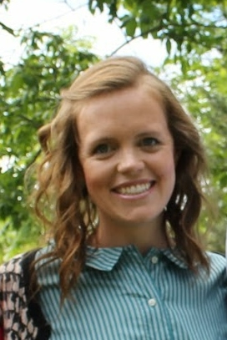
I am currently working on estimating environmental damages due to increased wildfire as a result of climate change within the US. We are evaluating a baseline and policy scenario to understand potential avoided environmental damages stemming from wildfire. We are building on past work we have done for DOJ evaluating environmental damages of wildfires in several national forests in California.

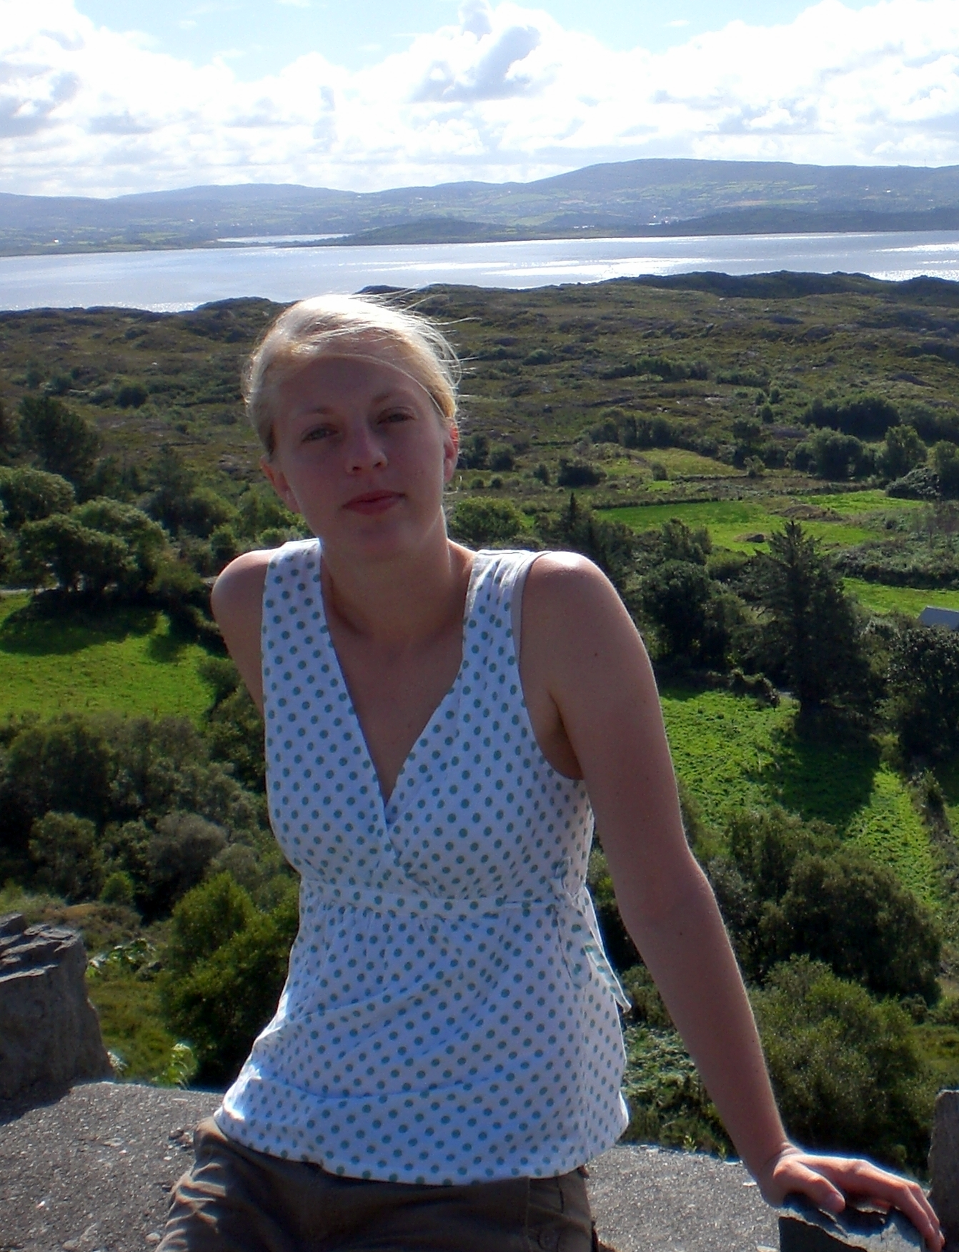
Sara Smiley-Smith ’07 M.E.Sc./M.P.H., ’14 Ph.D.
Program Manager, Environmental Studies Program, Yale College, and Doctoral Candidate

I am completing my dissertation exploring problem definition, decision making, and institutional sustainability. Working to strengthen the current curriculum as well as the diversity of course offerings for the Yale College Environmental Studies Program while also managing operations for the program.

